1. Figure 1 and Figure 2 shows the output voltage from the LVDT-beam setup at controlled loads and controlled deflections. Both data are highly linear as shown with the linearly fitted lines. The coefficient of determination, $R^{2}$, value of the linear fits to the two sets of data are 0.9991 and 1.0 respectively. The coefficient equation is: $R^{2}=1-\frac{\sum{{\left(y-y_{fit}\right)}^{2}}}{\sum{{\left(x-\overline{x}\right)}^{2}}}$

The high linearity suggests the slopes can be the sensitivity of the LVDT for loads and displacements. The original data of the two sets are shown in Table 1 and Table 2 below.

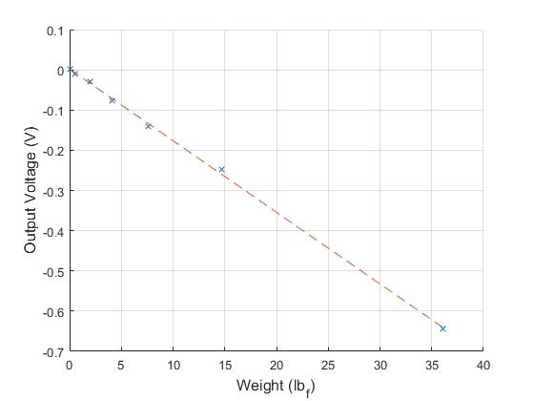

Figure : Controlled Masses versus Output Voltage

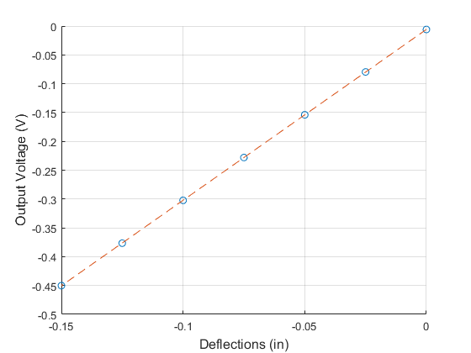

Figure : Controlled Deflections versus Output Voltage

Bucket mass = 7.65 g = 0.0169 lbm.

Table : Controlled mass loading and output voltage measurements

|  |  |
| --- | --- |
| Masses (lbm)* | Voltage Output (mV) |
| 0 [0 g] | 1.335 |
| 0.0169 [7.65 g] | -10.475 |
| 0.0610 [27.65 g] | -28.59 |
| 0.1271 [57.65 g] | -76.09 |
| 0.2373 [107.65 g] | -140.55 |
| 0.4578 [207.65 g] | -247.43 |
| 1.1192 [507.65 g] | -643.76 |

* all values include the mass of the bucket, values in brackets are original measurements

The pound mass is converted to pound force by multiplying by 32.2 ft/s2 for the plots.

Table : Controlled deflections and output voltage measurements

|  |  |
| --- | --- |
| Deflections (in) | Voltage Output (mV) |
| 0 | -5.9836 |
| -0.025 | -79.61 |
| -0.05 | -153.93 |
| -0.075 | -227.99 |
| -0.1 | -302.31 |
| -0.125 | -376.57 |
| -0.150 | -450.23 |

This linearity is only expected to hold when the input signal frequency is within the bandwidth of the LVDT.

1. Spring constant k has units of force/distance, or load/deflection, can be found after matching the voltage output of weight response to the voltage output of the deflection response.

The weight equivalent deflections are found to be:

|  |  |
| --- | --- |
| Weight (lbf) | Deflection (in) |
| 0 | 35.62 |
| 0.0169 | 14.32 |
| 0.0610 | 7.22 |
| 0.1271 | 3.67 |
| 0.2373 | 1.54 |
| 0.4578 | 0.12 |
| 1.1192 | -0.42 |

Polyfitting this data to a line gives a slope of 9166.5, suggesting the spring constant of the beam to be 166.5 lbf/in. The negative sign simply indicates weights are equivalent to negative deflections. The data and polyfitted line is shown in Figure 3:

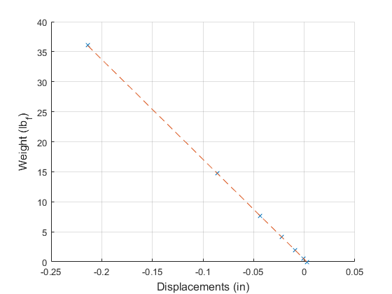

Figure : Weight vs. Deflection of the beam to find spring constant K

1. The linearity of the data suggests the sensitivity of the LVDT for deflection to be equal to the slope of the voltage versus deflection fit line: 2.9643 V/in.